**Question part 1 Test Cases Shown changes step by step to the cases until being fully sorted**

Default case sort step by step shown

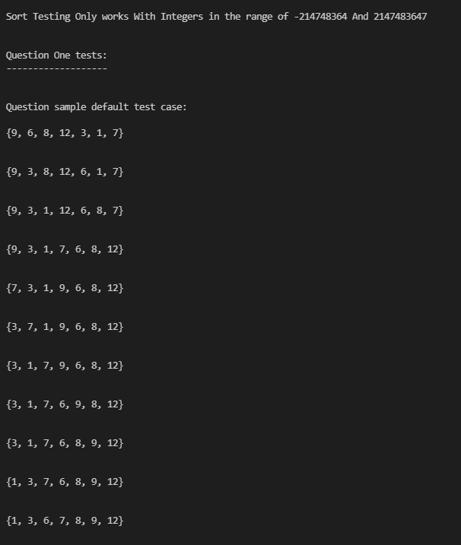

10 Integer test case

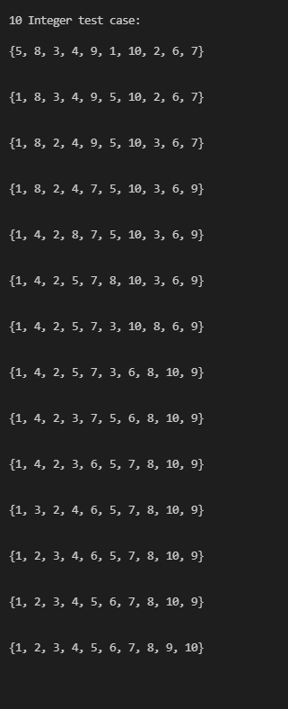

20 Integer list case

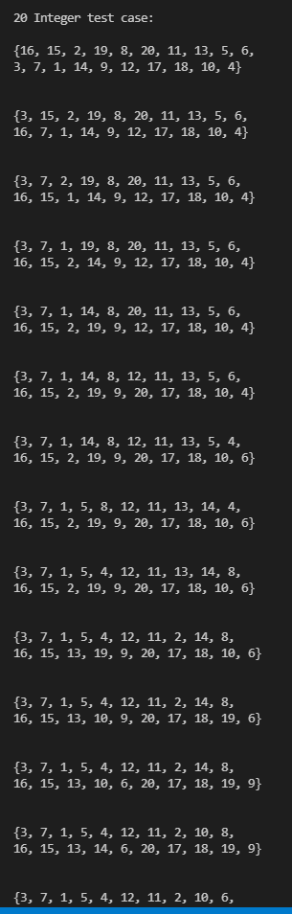

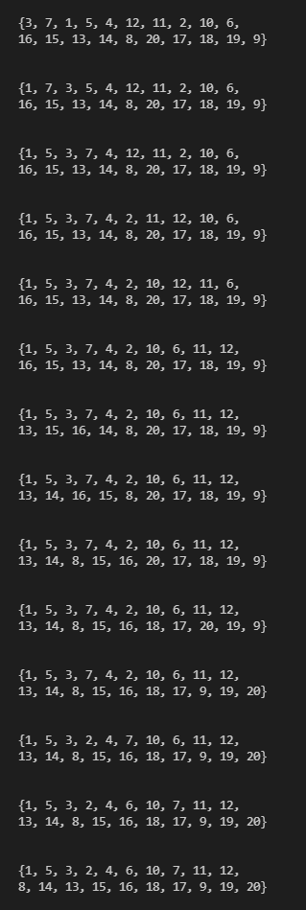

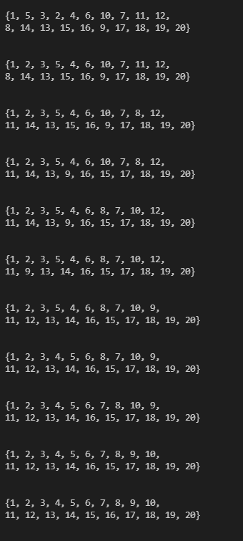

**Question Part 2**

10 Integer list unsorted with Bubble sort algorithm

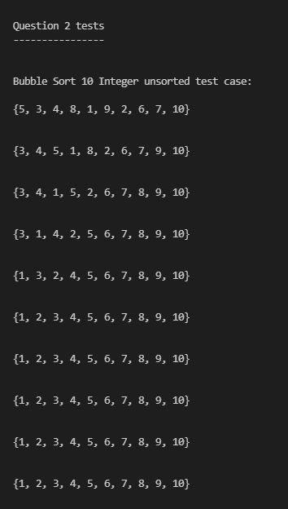

Test case of previous list but already sorted with bubble sort algorithm

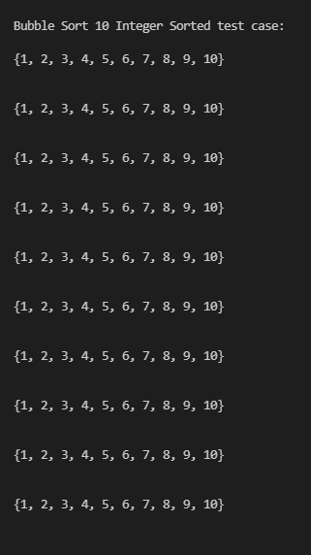

Now bubblesort2 algorithm test with the same test case. One iteration with a list unsorted and sorted.

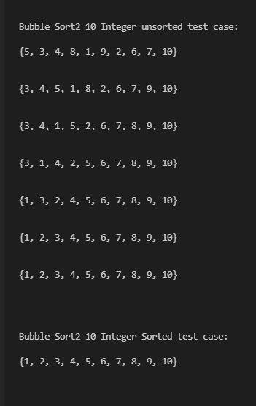

**Question Part 3**

Here is the randomly generated 100 integer list test case

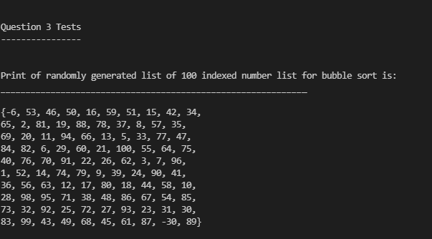

Bubble sort result of unsorted 100 integers list

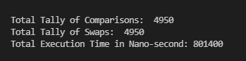

Bubble sorted result of sorted 100 integers list

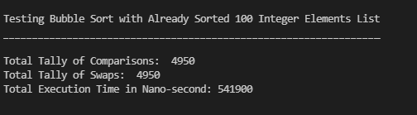

100 element integers shell sort test - unsorted

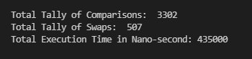

100 element integers shell sort test - sorted

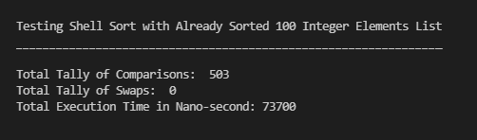

100 element integers BubbleSort2 test - unsorted

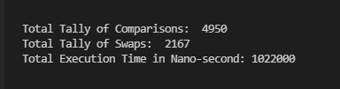

100 element integers BubbleSort2 test - unsorted

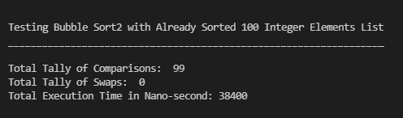

10 element integers BubbleSort test - unsorted

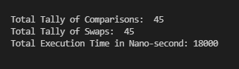

10 element integers BubbleSort test - sorted

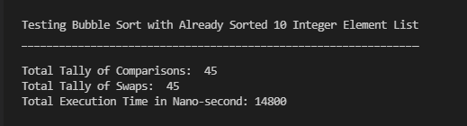

10 element integers shell sort test - unsorted

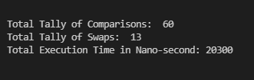

10 element integers shell sort test - sorted

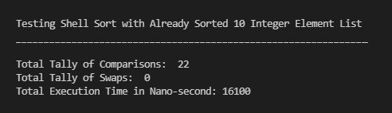

10 element integers BubbleSort2 test - unsorted

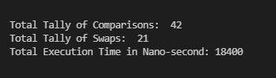

10 element integers BubbleSort2 test - sorted

